How to use Unsloth in Google Colab
Before installing unsloth, you need to check the pytorch and cuda version in google colab environment.
Then you need to install protobuf (3.20.3) and fsspec (2023.1.0)
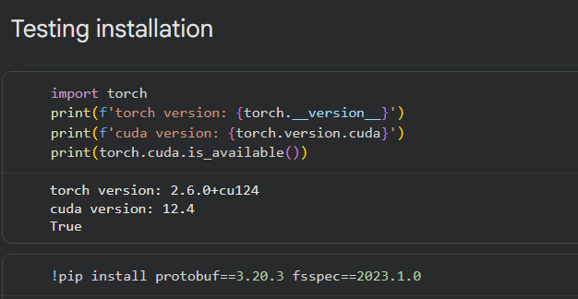
After knowing what version your pytorch and cuda
You can find the link at here https://github.com/unslothai/unsloth
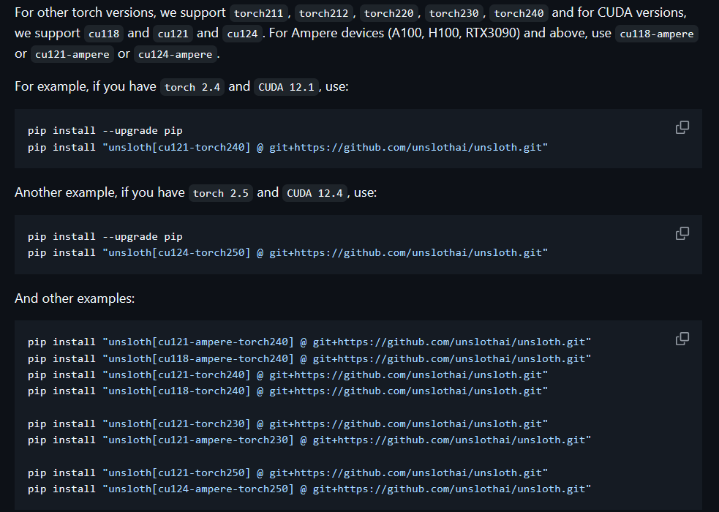
You need to install the right unsloth to that version.
You can find the right version using this command
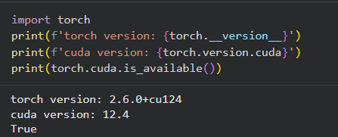
Then install this specific package version
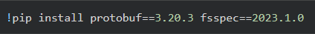
If you done everything above and there is no error, you can now download unsloth.
Remember to choose the correct unsloth version!
Now let try importing Llama-3.1-8B into the environment.
from unsloth import FastLanguageModel
import torch
max_seq_length = 2048 # Choose any! We auto support RoPE Scaling internally!
dtype = None # None for auto detection. Float16 for Tesla T4, V100, Bfloat16 for Ampere+
load_in_4bit = True # Use 4bit quantization to reduce memory usage. Can be False.
And if you successfully imported unsloth, you would see this output.

Now import the LLM.
model, tokenizer = FastLanguageModel.from_pretrained(
model_name = "unsloth/Meta-Llama-3.1-8B",
max_seq_length = max_seq_length,
dtype = dtype,
load_in_4bit = load_in_4bit,
# token = "hf_...", # use one if using gated models like meta-llama/Llama-2-7b-hf
)
And you will see this output
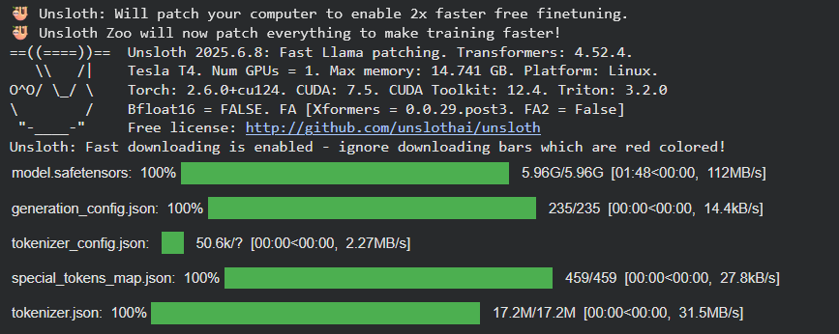
That mean, you have successfully imported the Llama-3.1-8B into the environment. Now you can start fine-tuning the Llama-3.1-8B or other LLM that unsloth support.
You can see what LLM that unsloth at here
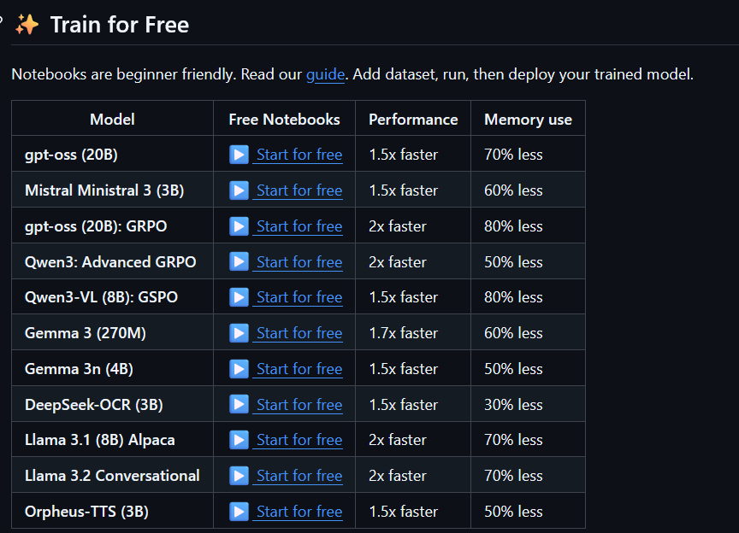
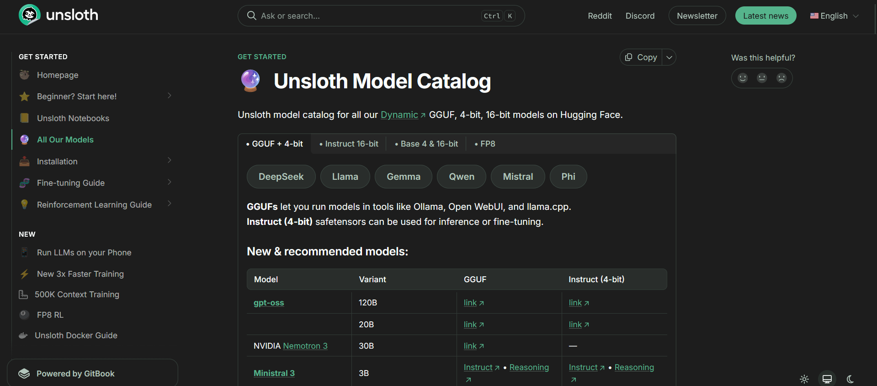
Keep in mind that some LMM may required more configuration, which you can find in Unsloth docs.

